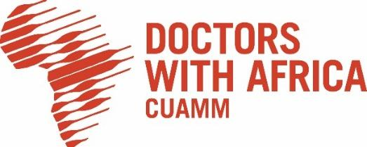
LOCAL OPEN TENDER NOTICE

Medical gases supply upgrading works for Black lion (Tikur Anbessa) Specialized Hospital Neonatal Intensive Care Unit – NICU

Ref. Nr.: 15/CUAMM/ETH/2026/AID 012958

The International NGO, Doctors with Africa CUAMM, under the project titled ““Strengthening Neonatology in Ethiopia - AID 012958” rénovation of Black Lion Hospital NICU in Addis Ababa, Ethiopia”, is launching the present Local Open Tender to select eligible suppliers for Medical gases supply upgrading works for Black lion (Tikur Anbessa) Specialized Hospital Neonatal Intensive Care Unit – NICU
Please find the complete tender dossier at the following link:

https://doctorswithafrica.org/en/get-involved/tender/open-tender-for-medical-gases-supply/.

or collect it at Doctors with Africa CUAMM main office at the following address:
Bole Subcity, Woreda 3, House nr. 2434, Addis Ababa.

Tender offers can be delivered by hand-delivery or by post at the same address.
Tender submission deadline is June 12th, 2026, 5 PM.

Please deliver all the documentation listed in the Annex XIII – Check List.

The public tenders opening session will be held according to the timetable provided in the tender dossier at Doctors with Africa CUAMM main office, Addis Ababa.

