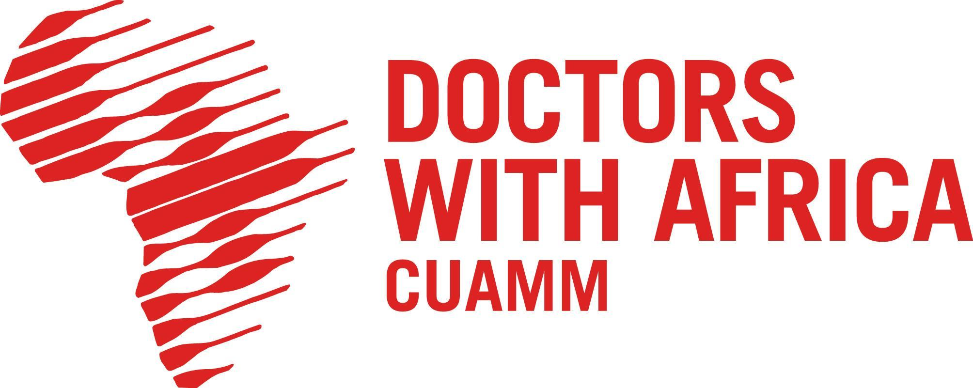

Addis Ababa, MAY 11th, 2026

INVITATION TO TENDER

Our ref.: 15/CUAMM/ETH/2026/AID 012958

SUBJECT: "Medical gases supply upgrading works for Black lion (Tikur Anbessa) Specialized Hospital Neonatal Intensive Care Unit – NICU"

PROJECT : “Strengthening Neonatology in Ethiopia - AID 012958” Renovation of Black Lion Hospital NICU in Addis Ababa, Ethiopia.

Dear Madam/Sir,
The NGO Doctors with Africa CUAMM, under, its projects implementation in Ethiopia, is launching the present Open Tender procedure to select eligible contractors for the Medical gases supply upgrading works for Blacklion (Tikur Anbessa) Specialized Hospital Neonatal Intensive Care Unit – NICU

DOSSIER
01 CONTRACT NOTICE
02 INSTRUCTIONS TO TENDERERS
03 TENDER FORM
ANNEXES
- Declaration of honour on exclusion and selection criteria ANNEX I
- Legal entity file ANNEX II
- Financial capacity ANNEX III
- Technical and professional capacity ANNEX IV
- Financial identification form ANNEX V
- Administrative compliance grid ANNEX VI
- Evaluation grid ANNEX VII
- Contract form ANNEX VIII
- General Conditions for Work Contract ANNEX IX
- Contract Special Conditions ANNEX X
- Technical Specifications ANNEX XI
- Financial Offer Template - BOQ ANNEX XII
- Check List ANNEX XIII

For full information about procurement procedures please consult the practical guide and its annexes, which can be downloaded from the following web page: http://ec.europa.eu/europeaid/funding/about-funding-and-procedures/procedures-and-practical-guide-prag_en
We look forward to receiving your tender which has to be submitted no later than June, 12, 2026 at 5 PM. Please send it to the address and with the requirements given in point 7. By submitting a tender, you accept notification of the outcome of the procedure by electronic means. Such notification shall be deemed to have been received by you on the date upon which the contracting authority sends it to the electronic address you referred to in your offer.

Looking forward to receiving your tender, sincerely,

Biruk Admasu
Logistics and Operation.
Doctors with Africa CUAMM

